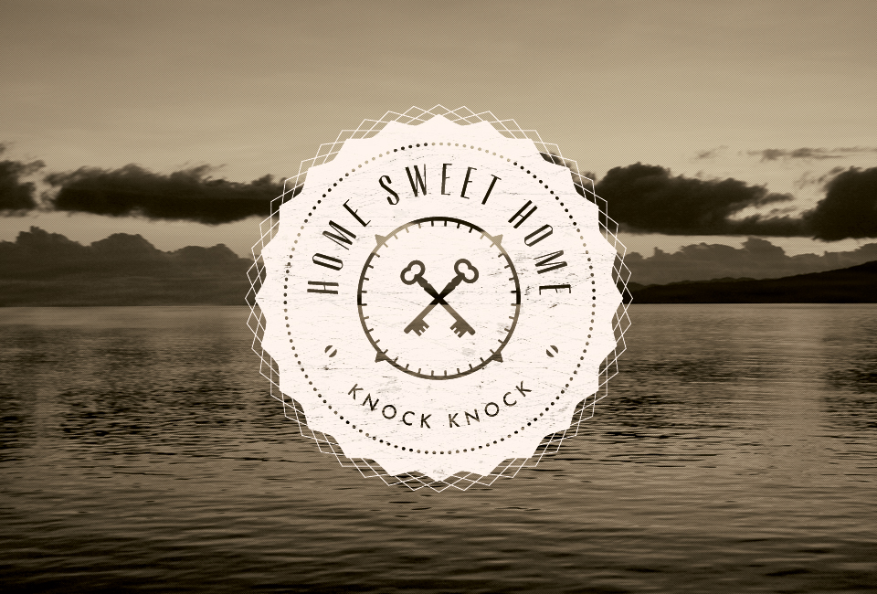

Home Sweet Home

#WhatIsHome

“Home is not where you live,
but where they understand you”
Christian MorgEnstern

Home Sweet Home “24/7” Questionnaire

So you’re on the road pretty much 24/7 and would like to fill us in on that ;) Awesome! We’re really looking forward to reading your stories. Please feel free to add photos or videos (the more the merrier), so we really get a feeling on what "home" means to you. Talking about photos … it would really be great if you could add a picture of yourself because it’s nice to see a face to the story :)

You can either send us the photos (min. width 600px) via e-mail (nisa@cookiesound.com) or sendspace (http://www.sendspace.com/).

Each and every filled out questionnaire will be featured on our website as part of the "Home Sweet Home" series. We’ll also share it with our readers on facebook & twitter. This project lives on diversity, so it would be great if you'd help us spread the word by using the official twitter #WhatIsHome hashtag.

If you have any questions, don’t hesitate to drop us a line at nisa@cookiesound.com or @cookiesound on twitter. Enjoy!

Name:
Email (will not be published):
Website URL:
Twitter URL:

- Tell us a little bit about yourself and how your passion for travelling started.

- When did you decide to hit the road? Was it hard to take that step? What preparations and arrangements did you have to make during the planning period?

- Where & how do you celebrate Christmas?

- How do you stay in touch with family and friends? Do you write postcards?

- Are you planning on travelling for the rest of your life or would you like to settle down sometime (by settling down we mean finding a place to come home to)?

- If you could choose one city/country for living, which one would it be? Please give us a little explanation (weather, people, etc.).

- Where are you right now and how did you get there?

- Travelling is expensive … so how do you get from A to B?

- Do you use a travel guide (Lonely Planet, etc.)? If so, please tell us which one … if not, why?

- What does a perfect day on your trip look like? What season is it? Are you inside or outdoors? Are you in a city or in the middle of nowhere?

- Name three spots from your last adventure, which you’d probably not find in a guidebook but you could recommend to travellers. Tell us what’s special about them.

- Where & how do you write your blog articles? Do you start with a rough draft or get right to it?

- What’s your favorite local dish? Where does it come from? Can you cook it & what are the main ingredients?

- How much does 1 liter (or one gallon) of milk and petrol cost today?

- On which device to you answer this questionnaire and what shoes are you wearing (if possible please add a picture )?

- Last but not least: What does “home” mean to you?

